For testing OnPrem we can use t-systems hsd19 environment in their Innovation Center. OnPrem installation was done in the week of 21st August, i.e. it is not the actual version.

A special CollaBoard client T-systems OnPrem exists which can downloaded from the Store or be installed from appx.

The sysadm professionals running this environment are from ceterion a contractor for t-systems. They have installed the certificates and helped Chrigi to do the initial install. They are [fabian.flanhardt@ceterion.com](mailto:fabian.flanhardt@ceterion.com) and [sascha.jung@ceterion.com](mailto:sascha.jung@ceterion.com) . Fabian did the install with Chrigi.

Actually the Client cannot access the OnPrem server.

We can get all the support needed from these people to get CB OnPrem running here.

Login: <https://myapps.microsoft.com>

User: [ibv.admin@hds19.com](mailto:ibv.admin@hds19.com)

Pw: adm4CBD2019!

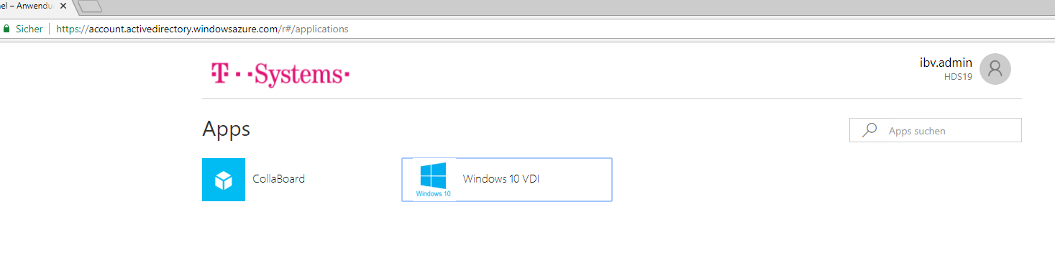

After Starting Windows10 Vdi you get the option to Run 3D Desktop:

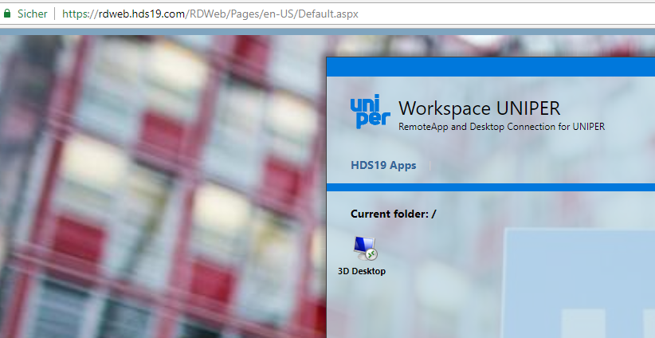

After you login to the virtual 3D Desktop you are on a Windows 10 Client with rpd to the OnPrem CollaBoard Server.

